9.6-9.9, 9.11, 9.12, 9.15, 9.17-9.20, 9.23, 9.24, 9.29, 9.31, 9.32, 9.36, 9.37, 9.41-9.48, 9.51-9.56, 9.58, 9.61-9.63, 9.65

9.6 Potential energy is associated with the relative position of an object, whereas kinetic energy is associated with motion.

9.7 Internal energy is the combined kinetic and potential energies of the atoms and molecules that make up a substance or object.

9.8 v=0.746m/s

9.9 6.0×10-20 J

9.11 PV = FV/A = N⋅m3/m2 = N⋅m = J = W

​9.12 0.331 kJ

9.15 (A) 3.60×103 cal; (B) 5.9×105 J; (C) 3.00×10-5 Btu

9.17 ΔE = +6.83×104 kJ

9.18 (A) q = -18 J; (B) ΔE = +64J

9.19 If the change in ΔE is negative, then energy has flowed from the system into the surroundings.

9.20 The first law of thermodynamics states that energy cannot be created nor destroyed. It can only be transformed from one form into another. In other words, the total energy in the universe is constant.

9.23 A

9.24 none

9.29 Calorimetry is the experimental technique for measuring the heat flow into or out of a thermodynamic system.

9.31 q = 3.50×105 J

9.32 1.12 kg

9.36 Calibration is a calorimetric measurement step in which a known amount of heat is generated in an apparatus.

9.37 C­cal = 383 J/℃

9.41 Enthalpy change is equal to the heat of the process under conditions of constant pressure.

9.42 Enthalpy is generally more useful than internal energy in the thermodynamics of real world systems because constant pressure conditions are more common.

9.43 Exothermic is a process in which heat flows out of a thermodynamic system. For a chemical reaction, this means that ΔH is negative. Endothermic is a process in which heat flows into a thermodynamic system. For a chemical reaction, this means that ΔH is positive.

9.44 Phase changes that are exothermic are freezing, condensation, and deposition.

9.45 When a material undergoes an endothermic phase change, the temperature remains constant. If heat is added, the temperature behaves in this manner because energy is being used to overcome intermolecular forces.

9.46 +8.10 kJ

9.47 -3.4×102 kJ/mol

9.48 q­tot= 5179 J

9.51 A formation reaction is a chemical reaction in which one mole of a compound is formed from its constituent elements in their standard states.

9.52 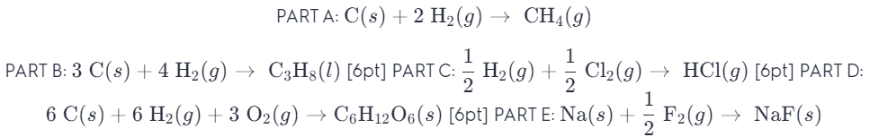

9.53 -217.3 kJ and -262.2 kJ

9.54 -2.43 kJ

9.55 

9.56 (A) -1299.5 kJ/mol; (B) -92.5 kJ/mol; (C) -45.6 kJ/mol; (D) -852 kJ/mol

9.58 

9.61 -699 kJ

9.62 -2.7×106 kJ

9.63 4.8×102 kJ

9.65 31.9 g/mol